%%%%%%%%%%%%%%%%%%%%%%%%%%%%%%%%%%%%%%%%%%%%%%%%%%%%%%%

**Example 2**

We solve aggregation-diffusion equation with a source term in the unit circle, i.e., $Ω=\{(x,y)| x^{2} + y^{2} ≤ 1\}$. We set $T = 0.1$, H = $ρ\log{ρ}-ρ$, $V = 0.01sin{(0.5pi(x^{2} + y^{2}))}$, and $W = 1$. The exact solution is given by:



%%%%%%%%%%%%%%%%%%%%%%%%%%%%%%%%%%%%%%%%%%%%%%%%%%%%%%%

**Result**

1. **Free energy**
2. **Mesh size(h=1/2), time step(tau=1/40000)**

The free energy at T=0: 5.501897e+02

The free energy at T=5.000000e-03: 5.450912e+02

The free energy at T=1.000000e-02: 5.400409e+02

The free energy at T=1.500000e-02: 5.350384e+02

The free energy at T=2.000000e-02: 5.300833e+02

The free energy at T=2.500000e-02: 5.251750e+02

The free energy at T=3.000000e-02: 5.203132e+02

The free energy at T=3.500000e-02: 5.154973e+02

The free energy at T=4.000000e-02: 5.107269e+02

The free energy at T=4.500000e-02: 5.060017e+02

The free energy at T=5.000000e-02: 5.013211e+02

The free energy at T=5.500000e-02: 4.966847e+02

The free energy at T=6.000000e-02: 4.920922e+02

The free energy at T=6.500000e-02: 4.875430e+02

The free energy at T=7.000000e-02: 4.830368e+02

The free energy at T=7.500000e-02: 4.785732e+02

The free energy at T=8.000000e-02: 4.741517e+02

The free energy at T=8.500000e-02: 4.697720e+02

The free energy at T=9.000000e-02: 4.654336e+02

The free energy at T=9.500000e-02: 4.611362e+02

The free energy at T=1.000000e-01: 4.568793e+02

1. **Mesh size(h=1/4), time step(tau=1/40000)**

The free energy at T=0: 5.906097e+02

The free energy at T=5.000000e-03: 5.848914e+02

The free energy at T=1.000000e-02: 5.792285e+02

The free energy at T=1.500000e-02: 5.736203e+02

The free energy at T=2.000000e-02: 5.680663e+02

The free energy at T=2.500000e-02: 5.625661e+02

The free energy at T=3.000000e-02: 5.571191e+02

The free energy at T=3.500000e-02: 5.517248e+02

The free energy at T=4.000000e-02: 5.463826e+02

The free energy at T=4.500000e-02: 5.410922e+02

The free energy at T=5.000000e-02: 5.358528e+02

The free energy at T=5.500000e-02: 5.306642e+02

The free energy at T=6.000000e-02: 5.255257e+02

The free energy at T=6.500000e-02: 5.204369e+02

The free energy at T=7.000000e-02: 5.153974e+02

The free energy at T=7.500000e-02: 5.104065e+02

The free energy at T=8.000000e-02: 5.054639e+02

The free energy at T=8.500000e-02: 5.005691e+02

The free energy at T=9.000000e-02: 4.957216e+02

The free energy at T=9.500000e-02: 4.909209e+02

The free energy at T=1.000000e-01: 4.861667e+02

1. **Mesh size(h=1/8), time step(tau=1/40000)**

The free energy at T=0: 6.007590e+02

The free energy at T=5.000000e-03: 5.948736e+02

The free energy at T=1.000000e-02: 5.890456e+02

The free energy at T=1.500000e-02: 5.832743e+02

The free energy at T=2.000000e-02: 5.775591e+02

The free energy at T=2.500000e-02: 5.718996e+02

The free energy at T=3.000000e-02: 5.662952e+02

The free energy at T=3.500000e-02: 5.607453e+02

The free energy at T=4.000000e-02: 5.552494e+02

The free energy at T=4.500000e-02: 5.498070e+02

The free energy at T=5.000000e-02: 5.444175e+02

The free energy at T=5.500000e-02: 5.390805e+02

The free energy at T=6.000000e-02: 5.337955e+02

The free energy at T=6.500000e-02: 5.285618e+02

The free energy at T=7.000000e-02: 5.233791e+02

The free energy at T=7.500000e-02: 5.182468e+02

The free energy at T=8.000000e-02: 5.131645e+02

The free energy at T=8.500000e-02: 5.081316e+02

The free energy at T=9.000000e-02: 5.031476e+02

The free energy at T=9.500000e-02: 4.982122e+02

The free energy at T=1.000000e-01: 4.933247e+02

1. **Mesh size(h=1/16), time step(tau=1/40000)**

The free energy at T=0: 6.037197e+02

The free energy at T=5.000000e-03: 5.977837e+02

The free energy at T=1.000000e-02: 5.919057e+02

The free energy at T=1.500000e-02: 5.860850e+02

The free energy at T=2.000000e-02: 5.803211e+02

The free energy at T=2.500000e-02: 5.746134e+02

The free energy at T=3.000000e-02: 5.689613e+02

The free energy at T=3.500000e-02: 5.633643e+02

The free energy at T=4.000000e-02: 5.578219e+02

The free energy at T=4.500000e-02: 5.523336e+02

The free energy at T=5.000000e-02: 5.468987e+02

The free energy at T=5.500000e-02: 5.415169e+02

The free energy at T=6.000000e-02: 5.361875e+02

The free energy at T=6.500000e-02: 5.309101e+02

The free energy at T=7.000000e-02: 5.256841e+02

The free energy at T=7.500000e-02: 5.205091e+02

The free energy at T=8.000000e-02: 5.153845e+02

The free energy at T=8.500000e-02: 5.103099e+02

The free energy at T=9.000000e-02: 5.052847e+02

The free energy at T=9.500000e-02: 5.003086e+02

The free energy at T=1.000000e-01: 4.953809e+02

1. **Mesh size(h=1/32), time step(tau=1/40000)**

The free energy at T=0: 6.039254e+02

The free energy at T=5.000000e-03: 5.979796e+02

The free energy at T=1.000000e-02: 5.920919e+02

The free energy at T=1.500000e-02: 5.862616e+02

The free energy at T=2.000000e-02: 5.804882e+02

The free energy at T=2.500000e-02: 5.747712e+02

The free energy at T=3.000000e-02: 5.691099e+02

The free energy at T=3.500000e-02: 5.635039e+02

The free energy at T=4.000000e-02: 5.579526e+02

The free energy at T=4.500000e-02: 5.524554e+02

The free energy at T=5.000000e-02: 5.470119e+02

The free energy at T=5.500000e-02: 5.416215e+02

The free energy at T=6.000000e-02: 5.362837e+02

The free energy at T=6.500000e-02: 5.309979e+02

The free energy at T=7.000000e-02: 5.257637e+02

The free energy at T=7.500000e-02: 5.205806e+02

The free energy at T=8.000000e-02: 5.154480e+02

The free energy at T=8.500000e-02: 5.103656e+02

The free energy at T=9.000000e-02: 5.053327e+02

The free energy at T=9.500000e-02: 5.003488e+02

The free energy at T=1.000000e-01: 4.954136e+02

1. **Order**
2. **Mesh size(h=1/2), time step(tau=1/40000)**

rho_L2_error_2 = 1.4794e-02

rho_H1_error_2 = 8.1140e-01

1. **Mesh size(h=1/4), time step(tau=1/40000)**

rho_L2_error_4 = 3.1056e-03 (Convergence order = 2.252090)

rho_H1_error_4 = 3.9340e-01 (Convergence order = 1.044427)

1. **Mesh size(h=1/8), time step(tau=1/40000)**

rho_L2_error_8 = 8.0691e-04 (Convergence order = 1.944376)

rho_H1_error_8 = 1.8714e-01 (Convergence order = 1.071898)

1. **Mesh size(h=1/16), time step(tau=1/40000)**

rho_L2_error_16 = 2.2869e-04 (Convergence order =1.819040)

rho_H1_error_16 = 9.6551e-02 (Convergence order =0.954723)

1. **Mesh size(h=1/32), time step(tau=1/40000)**

rho_L2_error_32 = 4.5062e-05 (Convergence order =2.343388)

rho_H1_error_32 = 4.8159e-02 (Convergence order =1.003494)

1. **Numerical result**

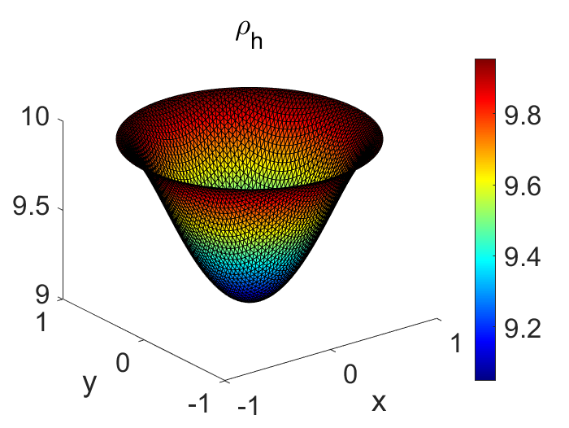

Figure 1 Mesh size(h=1/32), time step(tau=1/40000)